PROJECT 2: EXPLORATORY DATA ANALYSIS
Data Overview
The data set contains transaction sales records collected from an online retail business. It is intended for analyzing customer purchasing behavior, product performance, sales trends, and the impact of discounts and coupons on revenue generation.
Dataset Characteristics | Number of Records | Number of Variables | Data Type | Time Variable | Target of Analysis
Description | 1,200 | 14 | Structured transaction data | Date | Sales performance and customer transaction

Variables in the Data set are OrderID, CustomerID,TrackingNumber (Unique identifiers), Date ,Product,ItemsinCart, Quantity(number of units purchased), UnitPrice, TotalPrice, PaymentMethod, CouponCode, ReferralSource, ShippingMethod, OrderStatus

Data Quality Summary
Quality Check Result shows
- 309 missing values in CouponCode.
- No duplicate Record found
- No Invalid Dates
- TotalPrice was correctly computed as Quantity × UnitPrice
- Consistency in data
The data set was used to:
- Analyze sales trends over time.
- Identify best-selling products and categories.
- Evaluate customer purchasing patterns.
- Compare payment methods and shipping preferences.
- Determine revenue contributions by product category and location.
Missing Value Observation
The only missing values occurred in the CouponCode variable. These likely indicate transactions where no coupon was used and was treated as "No Coupon" during analysis.

DESCRIPTIVE STATISTICS
Variable | Mean | Median | Count | Minimum | Maximum
Quantity | 2.95 | 3.00 | 1200 | 1.00 | 5.00
UnitPrice | 356.41 | 364.21 | 1200 | 11.39 | 699.93
ItemsInCart | 5.49 | 5.00 | 1200 | 1.00 | 10.00
TotalPrice | 1053.97 | 823.62 | 1200 | 11.39 | 3456.40
The quantity purchased per transaction ranges from 1 to 5 units. This indicates that customers generally buy small quantities of products in a single transaction.
The unit price ranges from 11.39 to 699.93, showing a wide variation in product prices. This suggests that the dataset contains both low-cost and high-cost products.
Customers purchased between 1 and 10 items per cart. This indicates variation in shopping behavior, with some customers buying only a single item while others purchase multiple items at once.
The total transaction value ranges from 11.39 to 3456.40. The large difference between the minimum and maximum values suggests considerable variation in customer spending across transactions.
The mean Total Price (1053.97) is higher than the median Total Price (823.62), indicating a positively skewed distribution. This suggests that a small number of high-value transactions are pulling the average upward.

DISTRIBUTION ANALYSIS
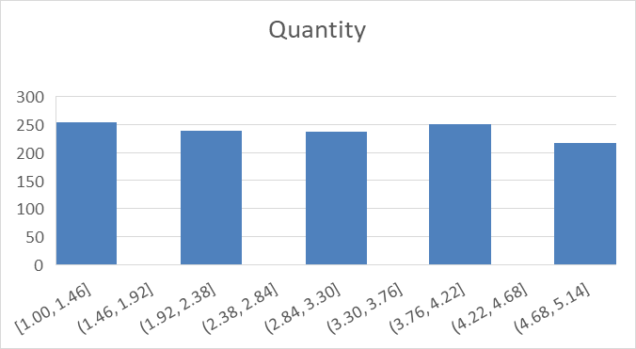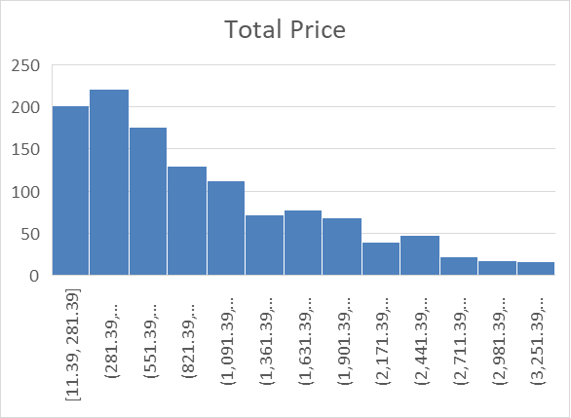
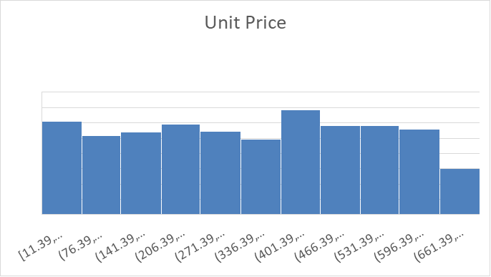
The diagrams above show that the total price is right skewed and has a wide and asymmetrical spread. The last few bars on the right are very short and separated from the main bulk of data indicating a few rare, unusually high transaction total.
The unit price is approximately uniform and evenly distributed spread across the entire horizontal axis.
The Quantity chart shows classic uniform distribution, meaning each interval occurs with roughly the same frequency
CORRELATION ANALYSIS
Correlation Analysis
Quantity vs Total price |  |  | 0.615251
Unit price vs Total price |  |  | 0.717081
Unit price vs Quantity |  |  | 0.014553

The table above shows a moderate positive relationship exist between quantity of items sold and the total price with correlational coefficient of 0.62, while unit price and total price has a strong positive relationship. There is no relationship between unit price and quantity of items sold.

OUTLIERS ANALYSIS
Interquatile Range Method(IQR) of Outlier Detection
Q1 | Q3 | IQR(Q3-Q1) | Lower Limit | Upper Limit
2.00 | 4.00 | 2.00 | -1.00 | 5.00
186.06 | 521.57 | 335.51 | -317.20 | 1024.83
4.00 | 7.00 | 3.00 | -0.50 | 11.50
410.52 | 1578.48 | 1167.96 | -1341.41 | 3330.41

OUTLIER IN TOTALPRICE(TOTAL PRICE>3330.41 OR <-1341.41) |  |  | Outliers Percentage (8/1200*100)
8 |  |  | 0.67

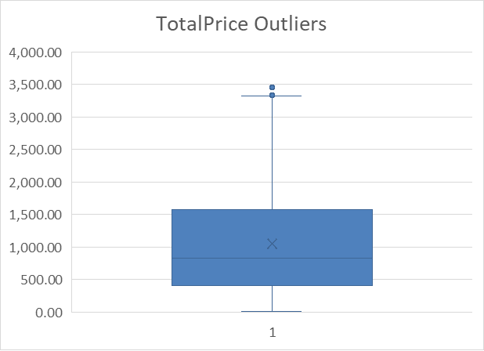
The IQR method identified 8 outliers in the Total Price column above the upper bound of 3330.41. These outliers represent less than 1% of all transactions, indicating that unusually high-value purchases are rare. The majority of transactions fall within the expected range, suggesting that the dataset is generally consistent.

Key Findings
- Total Sales was $1.26M
- Chair was the product that generated the highest revenue($195620.11) while the Phone was the product with the lowest revenue($151722.39).
- Most transactions over the years occurred in June 2024 with $68068.54 generated while the lowest sales month was October 2023 with $52607.85
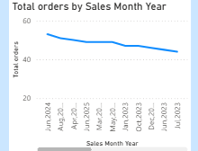

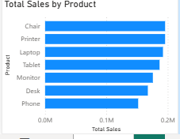
- Coupon users generated approximately75% of revenue..
- Customers with coupon made the highest revenue.
- Sale gradually decline across the period analyzed.
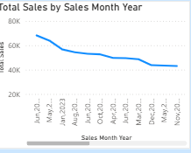

Conclusion
The sales analysis revealed that the business generated approximately $1.26M in total sales from 1200orders. Among all products, Chair generated the highest revenue, making it the top performing product. Customers who used coupons contributed a larger share of the total sales compared to those who did not use coupons. The analysis also showed a gradual decline in both sales and order volume over the period under review, indicating a downward sales trend. A small number of outlier transactions were identified, suggesting the presence of unusually high value orders. Overall, product performance and coupon usage were the key drivers of revenue, while the declining sales trend highlights the need for strategies to improve customer engagement and increase future sales.

RECOMMENDATION
- The company should increase promotion of high performing products such as Chairs.
- They should continue using coupon campaigns since coupon users generated more revenue.
- Investigation should be made to identify the causes of the decline in sales trend and implement targeted marketing efforts to boost sales.

